**NAAN MUDHALVAN**

**SALESFORCE DEVELOPMENT**

**IMPLEMENTING CRM FOR RESULT TRACKING OF A CANDIDATE**

**WITH INTERNAL MARKS**

**TEAM MEMBERS MENTOR**

1.S.Yuvashree(611420104095) Mr.K.A.Karthick AP/IT

2.S.Vennila Devi(611420104091)

3.G.Vinodha(611420104094)

4.S.Sowmiya(611420104077)

## TABLE OF CONTENTS

|  |  |  |
| --- | --- | --- |
| **CHAPTER NO.** | **TITLE** | **PAGE NO.** |
| **1** | **INTRODUCTION** |  |
| **2** | **PROJECT SPECIFICATIONS** |  |
|  | 2.1 Project Goal |  |
|  | 2.2 Project Scope |  |
|  | 2.3 Technical Requirements |  |
|  | 2.4 Functional Requirements |  |
| **3** | **PREPARATION DATA MODELING** |  |
| **4** | **USERS & DATA SECURITY** |  |
| **5** | **AUTOMATION** |  |
| **6** | **REPORTS & DASHBOARD** |  |
|  | GitHub & Project Video Demo Link |  |

1. **INTRODUCTION**

Salesforce, a leading cloud-based Customer Relationship Management (CRM) platform, is a pivotal tool for organizations to manage customer data, optimize sales processes, and elevate customer interactions. Its multifaceted features include Sales Cloud, which enhances sales management through lead tracking, opportunity management, and seamless email integration. Service Cloud focuses on exceptional customer support, featuring case management, knowledge base development, and multi-channel support. Marketing Cloud empowers businesses with marketing automation, email campaigns, social media engagement, and in-depth analytics. Salesforce's hallmark is its customizability, allowing businesses to tailor the platform to meet specific requirements, while robust integration capabilities facilitate seamless connections with other business applications.

The platform equips businesses with powerful reporting and analytics tools, enabling data-driven decisions and insightful, customized reports and dashboards. Salesforce ensures mobile accessibility, enabling users to stay connected and productive while on the move. A paramount emphasis on data security and compliance guarantees data protection and privacy. Whether you're a small start-up or a large enterprise, Salesforce offers scalability to accommodate your evolving needs.

Through Salesforce, organizations foster improved customer relationships, increased sales efficiency, and superior customer support. It empowers businesses to make data-driven decisions, streamline operations, and create impactful, targeted marketing campaigns. This introduction encapsulates Salesforce's capabilities and benefits, offering a concise overview for your project document, allowing for a better understanding of how the platform can contribute to your specific project goals.

# PROJECT SPECIFICATIONS

## Project Goal

The goal of this project is to create a CRM (Customer Relationship Management) application tailored for job applicants, designed to streamline the job application process. The application will allow users to track the number of job applications they have submitted and provide easy access to job postings from various recruiters. The project involves technical components such as creating a developer account, defining custom objects and relationships, configuring tabs, and building an application. Additionally, it covers user management, access control, reporting, and dashboards. The objective is to empower users to efficiently manage their job applications and access relevant job listings within the Salesforce platform.

## Project Scope

* + - **Creation of Developer Account (Milestone 1):** This involves setting up a developer account on the Salesforce platform, which will serve as the foundation for building the CRM application.
    - **Object Creation (Milestone 2):** Custom objects and relationships will be defined to efficiently store and manage data related to job applications, recruiters, and other relevant information.
    - **Tabs Creation (Milestone 3):** Tabs will be configured to provide user-friendly access to different sections and functionalities within the CRM application.
    - **Create App (Milestone 4):** The CRM application will be created, and it will serve as the central hub for managing job applications and accessing job postings.
    - **Fields & Relationships (Milestone 5):** Custom fields and relationships will be established to capture specific data attributes related to job applications and recruiters.
    - **Profile (Milestone 6):** User profiles will be configured to define access permissions and roles within the application.
    - **Role and Role Hierarchy (Milestone 7):** Role-based access control will be set up to determine who can view and edit specific data within the CRM.
    - **Users (Milestone 8):** User management will involve adding and configuring user accounts, specifying their roles and access levels.
    - **Sharing Rules (Milestone 9):** Sharing rules will be defined to ensure that users can appropriately share and access data based on predefined criteria.
    - **User Adoption (Milestone 10):** Strategies and tools will be implemented to encourage user adoption and make the application user-friendly.
    - **Reports (Milestone 11):** Custom reports will be created to track and analyse job application data, providing valuable insights for users.
    - **Dashboards (Milestone 12):** Dashboards will be designed to display key performance indicators and visual summaries of application data.
    - The project aims to create a comprehensive CRM application that helps job applicants track their applications and access job postings from recruiters. It covers the technical architecture, data modeling, and user adoption aspects of Salesforce. The scope is to deliver an efficient, user-friendly, and productive tool for managing the job application process within the Salesforce platform.

## Technical Requirements

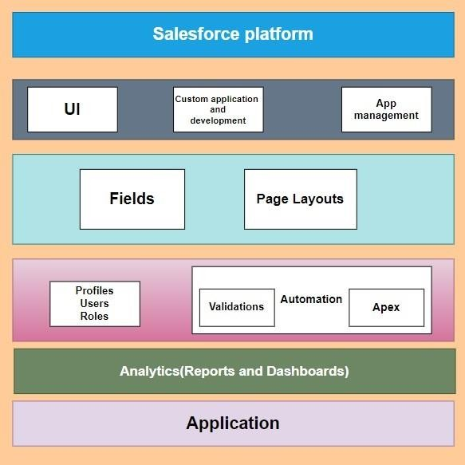

* 1. **Functional Requirements**
     + **User Registration and Authentication:** Users should be able to create accounts with unique usernames and passwords. User authentication and authorization should be implemented to ensure data security.
     + **Dashboard:** Users should have a personalized dashboard displaying key metrics such as the number of result applications submitted and the status of each application.
     + **Result Application Tracking:** Users should be able to record details of each result application, including the result title, company, date applied, application status, and any related notes. Users should be able to filter and search through their result applications.
     + **Result Postings:** Result postings from various recruiters should be accessible within the application. Users should be able to view details of result postings, such as result descriptions, qualifications, and application deadlines.
     + **Custom Objects and Relationships:** Custom objects for result applications, result postings, and recruiters should be defined with appropriate relationships. Relationships between applicants and their result applications, as well as between result applications and result postings, should be established.
     + **Profile Management:** Users should have the ability to edit their profiles and update personal information. Profiles should include user-specific settings and preferences.
     + **Role-Based Access Control:** Access permissions should be defined based on user roles (e.g., applicant, recruiter). Users should only have access to data and features relevant to their roles.
     + **User Management:** Administrators should be able to add, modify, or deactivate user accounts. User roles and permissions should be customizable.
     + **Sharing Rules:** Sharing rules should be configured to allow data sharing based on predefined criteria, ensuring privacy and data access control.
     + **Reporting:** Users should be able to generate custom reports based on their result application data. Standard reports and report templates should be available for common use cases.
     + **Notifications and Reminders:** Users should receive notifications and reminders for application deadlines, interview schedules, and other important events. Notifications can be delivered via email or within the application.
     + **Integration with External Platforms:** Integration with result search platforms or websites to import postings automatically. Integration with email services to track application-related correspondence.
     + **Data Import and Export:** Users should have the capability to import and export their application data for backup or transfer purposes.
     + **User Adoption Features:** Onboarding guides, tutorials, and tooltips to help users navigate and effectively use the system. Feedback mechanisms to collect user suggestions and improve the application.
     + **Customization and Configuration:** Administrators should be able to customize the application's appearance, fields, and workflows to suit their organization's needs.
     + **Mobile Accessibility:** The application should be accessible on mobile devices to allow users to track applications on the go.
     + **Security and Data Privacy:** Data encryption, secure connections, and compliance with data privacy regulations (e.g., GDPR) should be implemented to protect user data.
     + **Scalability:** The system should be scalable to accommodate a growing number of users, applications, and postings.
     + **Backup and Recovery:** Regular data backups and a disaster recovery plan should be in place to prevent data loss.

# PREPARATION DATA MODELING

#### Objects:

Salesforce objects are database tables that permit you to store data that is specific to an organization. It consists of fields (columns) and records (rows).

Salesforce objects are of two types:

* 1. Standard Objects: Standard objects are the kind of objects that are provided by salesforce.com such as users, contracts, reports, dashboards, etc.
  2. Custom Objects: Custom objects are those objects that are created by users. They supply information that is unique and essential to their organization. They are the heart of any application and providea structure for sharing data.

In This Application We Use 5 Custom Objects:

* + 1. Semester 2.Candidate 3.Course Detail 4.Lecturer Detail 5.Internal Result

**Creation Of Semester Object For Candidate Internal Result Card**

1. Click on the gear icon and then select Setup.
2. Click on the object manager tab just beside the home tab.
3. After the above steps, have a look on the extreme right you will find a Create Dropdownclick on that and select Custom Object.
4. On the Custom Object Definition page, create the object as follows:
5. Label: **Semester**
6. Plural Label: **Semesters**
7. Record Name: **Semester** Name
8. Check the **Allow Reports**
9. Check the **Allow Search** And Click Save.

In the same way create **4** more objects as **Candidate, Course Detail, Lecturer Detail** and **Internal result.**

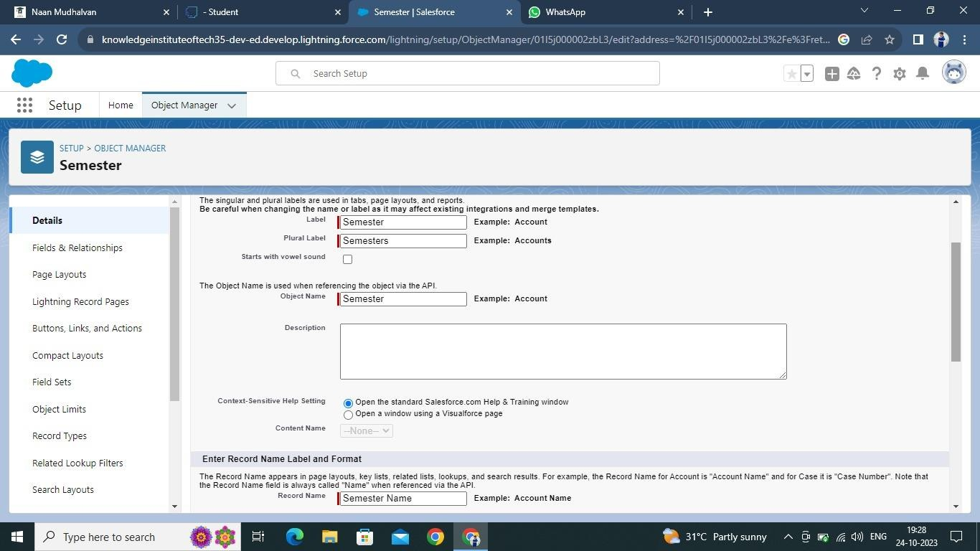

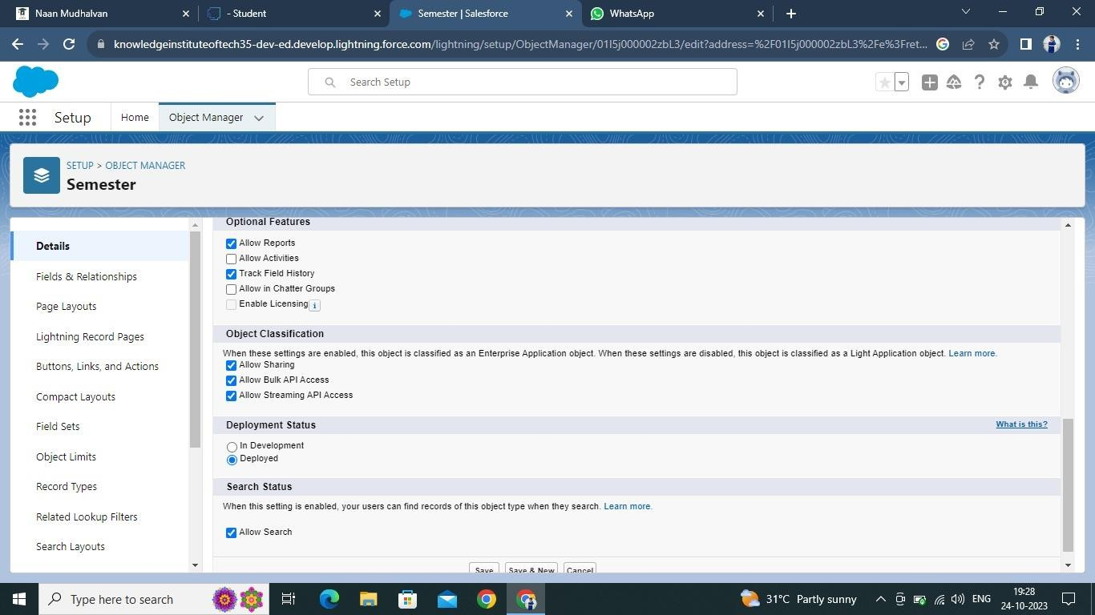

### What Is A Tab?

Tabs in Salesforce help users view the information at a glance. It displays the data of objects and other web content in the application.

There are mainly 4 types of tabs:

* 1. Standard Object Tabs: Standard object tabs display data related to standard objects
  2. Custom Object Tabs: Custom object tabs displays data related to custom objects.
  3. Web Tabs: Web Tabs display any external Web-based application or Web page in a Salesforce tabs.
  4. Visualforce Tabs: Visualforce Tabs display data from a Visualforce Page.

Now create a custom tab. Click the Home tab.

1. Enter Tabs in Quick Find and select Tabs.
2. Under Custom Object Tabs, click New.
3. For Object, select Semester.
4. For Tab Style, select any icon.
5. Leave all defaults as is. Click Next, Next, and Save
6. In the same way create Tabs for all Custom Objects -Candidate, Course Details, Lecturer Details, Internal results .

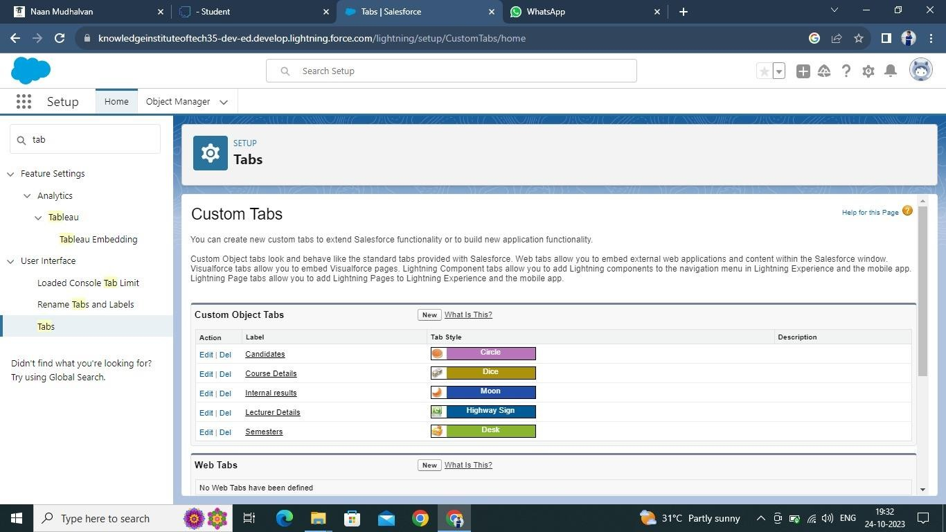

### Lightning App

Apps in Salesforce are a group of tabs that help the application function by working together as aunit. It has a name, a logo, and a particular set of tabs. The simplest app usually has just two tabs.

There are two types of app –

1. **Standard App:** Standard apps come with every occurrence of Salesforce as default. Many features like Sales, Marketing, Community, call center, content, Salesforce chatter, App Launcher, etc are present in it.

**Note:** The description, Logo, and Label of standard app cannot be altered.

**Custom Apps**: Custom apps are created according to need of user. Custom Apps are made by using standard and custom tabs together.

*Note: Logos for Custom Apps can be changed.*

### Create The Candidate Internal Result Card

1. From Setup, enter App Manager in the Quick Find and select App Manager.
2. Click New Lightning App.
3. Enter **Candidate Internal Result Card** as the App Name, then click next
4. Under App Options, leave the default selections and click next.
5. Under Utility Items, leave as is and click Next.
6. From Available Items, select **Semester, Candidate, Course Details, Lecturer Details, Internal results, Reports, and Dashboards** and move them to Selected Items.
7. Click Next.

From Available Profiles, select System Administrator and move it to Selected Profiles. Click Save & Finish.

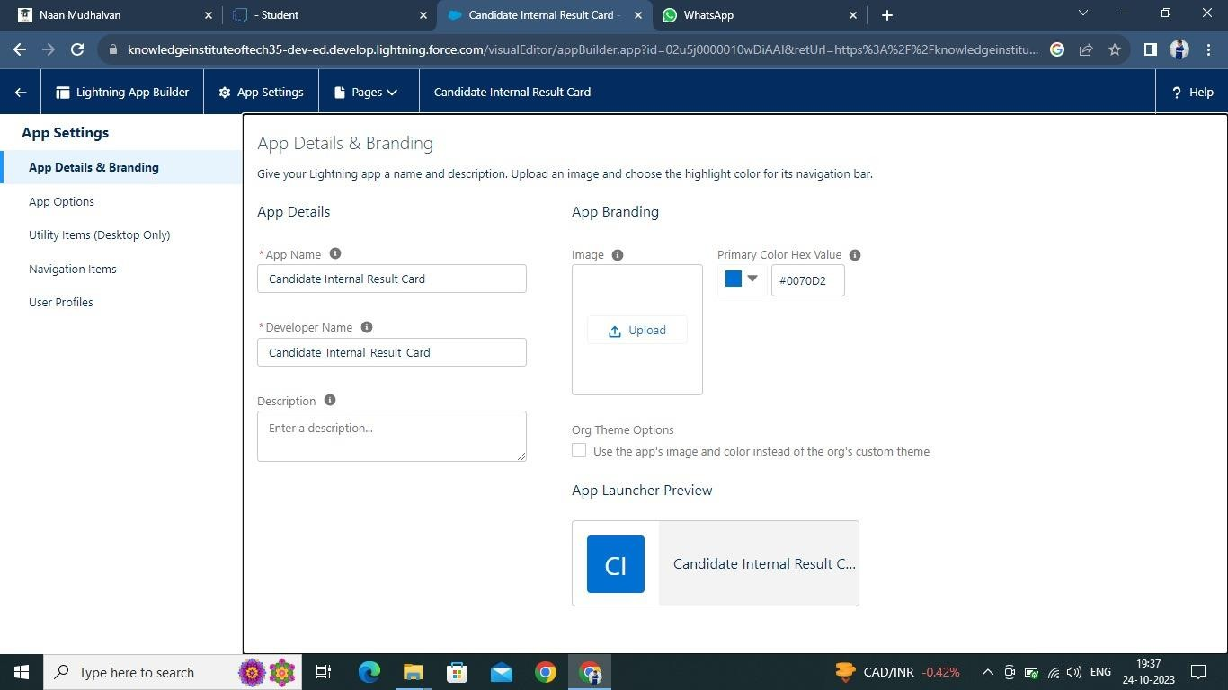

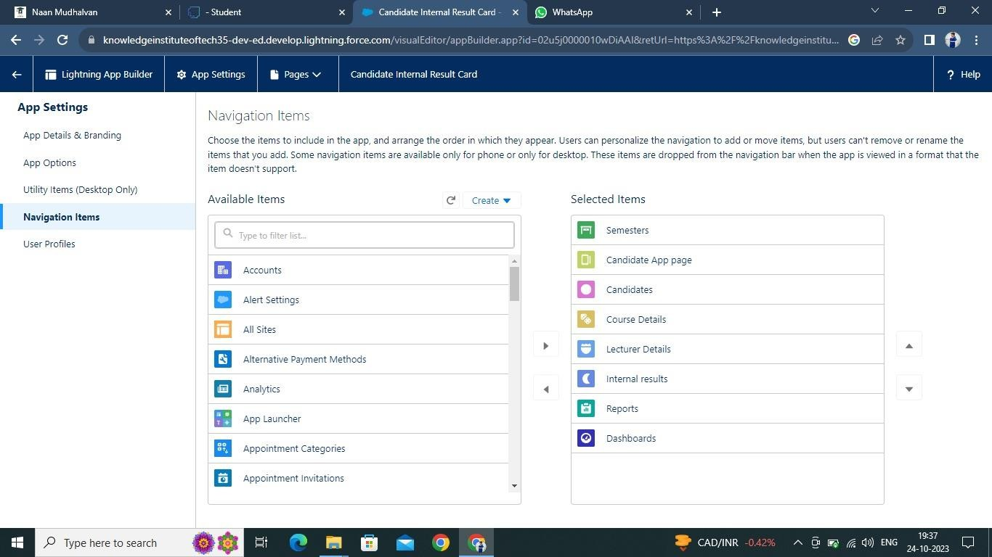

### Fields And Relationship

**Fields** - Fields store data values that are required for a particular object in a record.

An object relationship in Salesforce is **a two-way association between two objects**. Relationships are created by creating custom relationship fields on an object. This is done so that when users view records, they can also see and access related data.

### Creation Of Text Field For The “Lecturer Details” Object

* 1. Click the gear icon and select Setup. This launches Setup in a new tab.
  2. Click the Object Manager tab next to Home.
  3. Select **Lecturer Details**
  4. Select Fields & Relationships from the left navigation
  5. Click New
  6. Select the **Text** as the Data Type, click next.
  7. For Field Label, enter **Lecturer Role**
  8. Enter Length 40
  9. Click Next, Next, then Save & New.

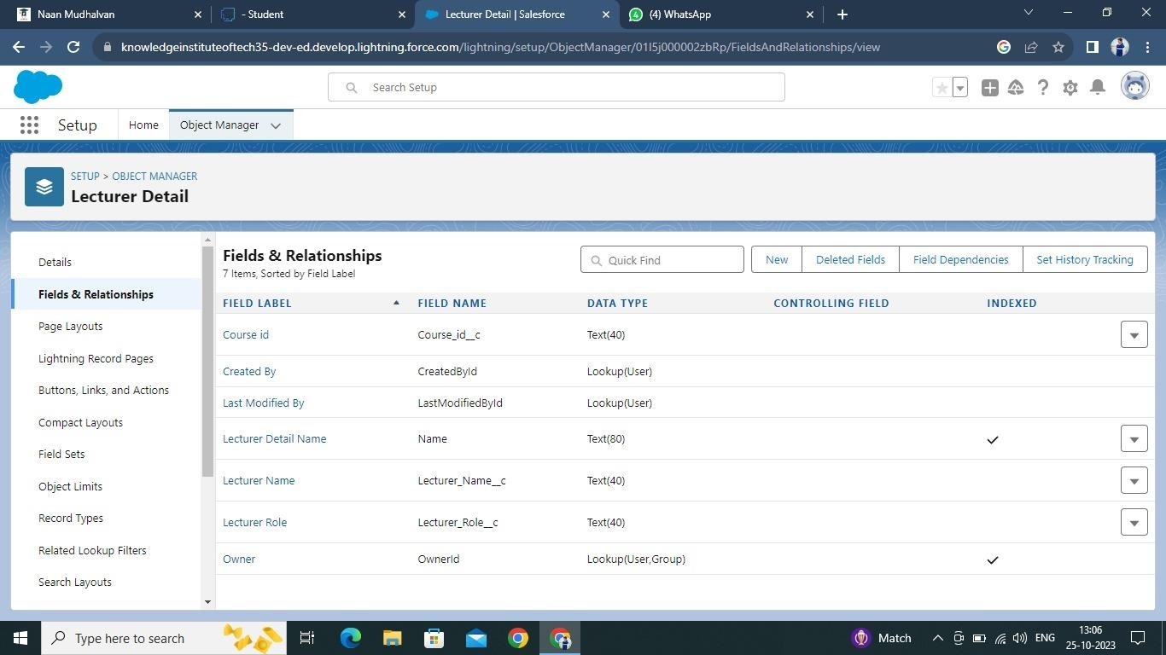

Lookup field on candidate object

1. Click the gear icon and select Setup. This launches Setup in a new tab.
2. Click the Object Manager tab next to Home.
3. Select candidate.
4. Select Fields & Relationships from the left navigation
5. Click New
6. Select the lookup as the Data Type, then click Next.
7. In related select **Semester**
8. For Field Label **Semester Name**, enter**.**
9. Click Next, Next, then Save & New

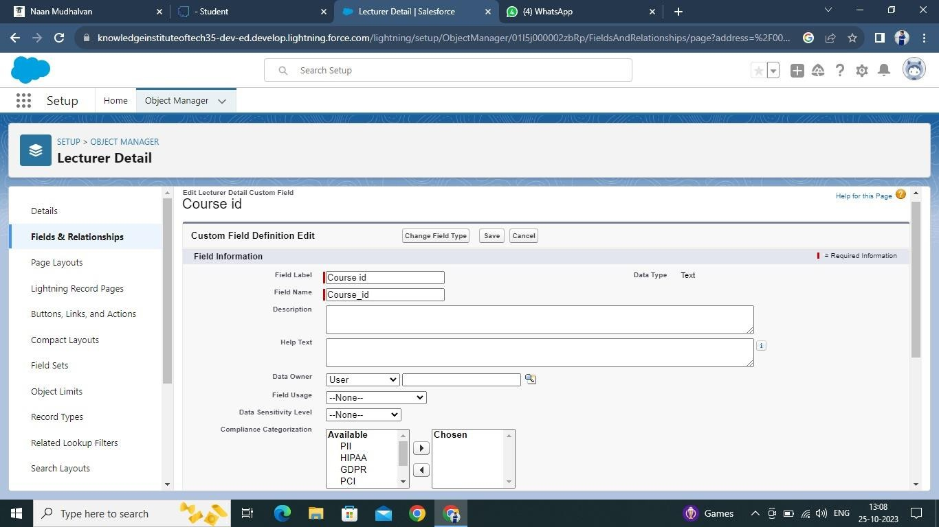

Note- Similarly create all lookup fields on their respective objects.

Let’s create an auto number field on **Candidate** object

1. Click the gear icon and select Setup. This launches Setup in a new tab.
2. Click the Object Manager tab next to Home.
3. Select **Candidate**.
4. Select Fields & Relationships from the left navigation
5. Click New
6. Select the Auto Number as the Data Type, then click Next.
7. For Field Label enter Candidate Roll Number**.**
8. Give a display format

10.Click Next, Next, then Save & New.

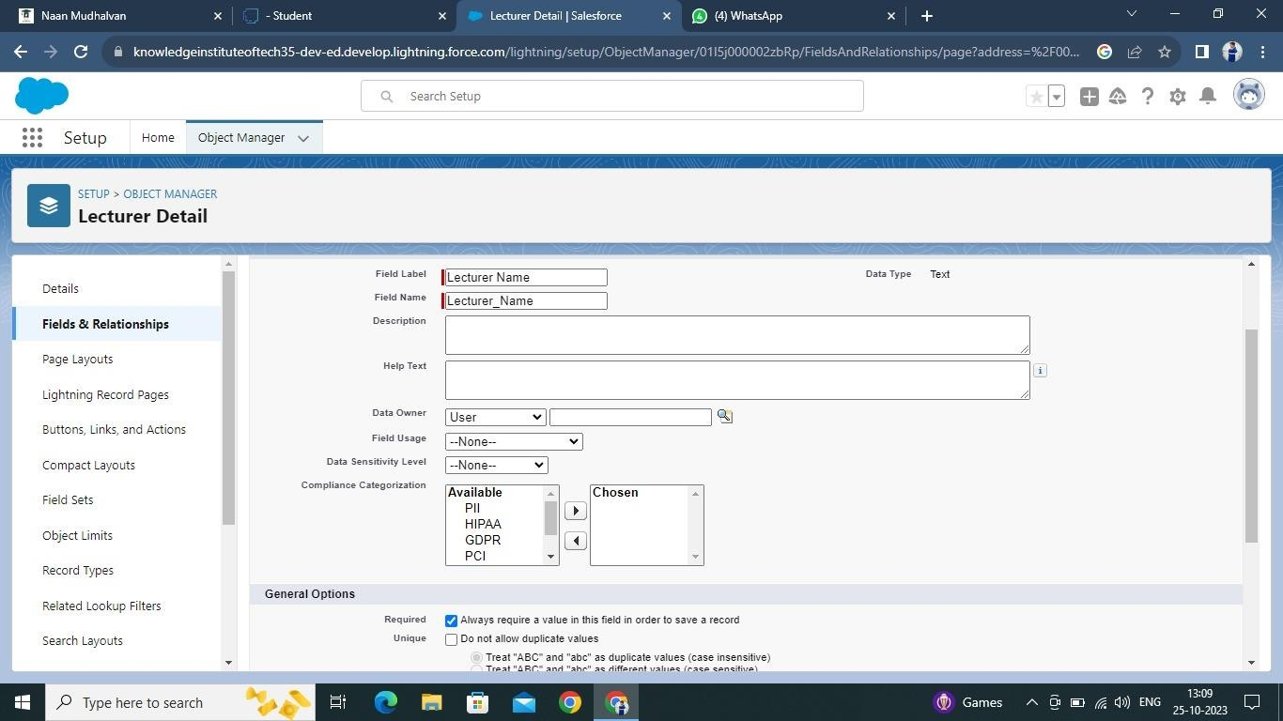

Let’s create a Formula field on **Internal results** object

1. Click the gear icon and select Setup. This launches Setup in a new tab.
2. Click the Object Manager tab next to Home.
3. Select **Internal results**.
4. Select Fields & Relationships from the left navigation.
5. Click New
6. Select the Formula as the Data Type, then click Next.
7. Give field label Candidate Roll Number
8. Select formula return type text, Click Next
9. Click Insert Field
10. Create and insert formula **Candidate r. Candidate Roll _ Number** , and then click Insert.
11. Click Next, Next, then Save.

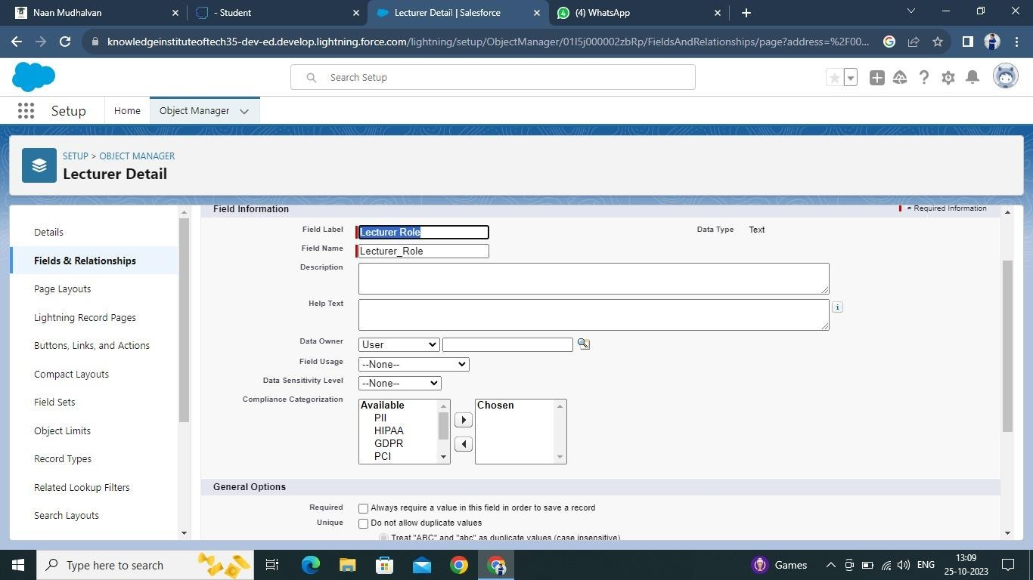

### Users

A user is **anyone who logs in to Salesforce**. Users are employees atyour company, such as sales reps, managers, and IT specialists, whoneed access to the company's records. Every user in Salesforce has a user account

### Creating A User

1. From Setup, in the Quick Find box, enter Users.
2. Select Users.
3. Click New User.
4. Enter the First Name, **Class,** Last Name, **Teacher** and (Your) email address anda unique username in the form of an email address. By default, the username is the same as the email address.
5. Select a User License as salesforce.

**NOTE** - As **Salesforce** license can only be used by 2 Users at a time in Dev Org, so If

you don’t find a salesforce license then deactivate a user who has a salesforce license Or change the license type from Salesforce to any other.

1. Select a profile as Standard user.
2. Check Generate new password and notify the user immediately to have the user’s login name and a temporary password emailed to your email.

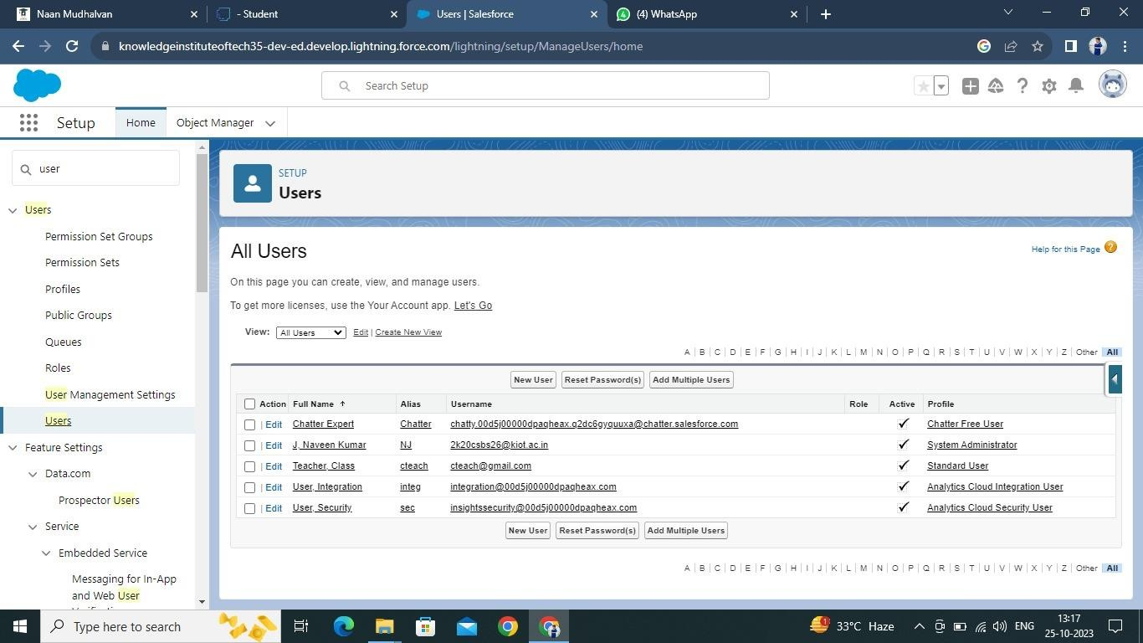

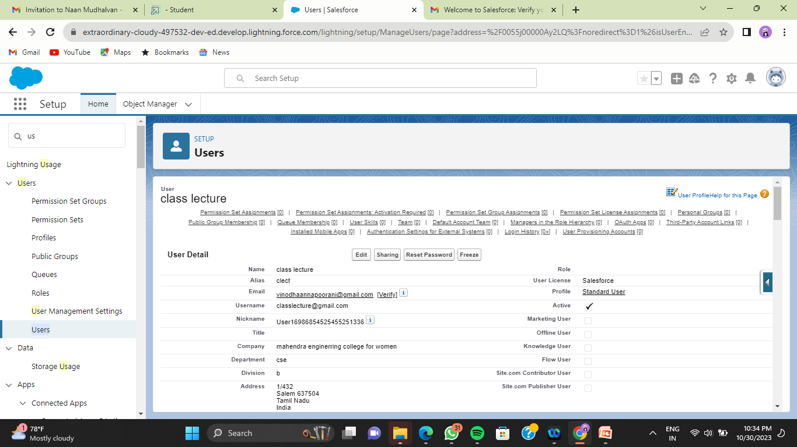

### Create Record (Course Details)

1. Click on App Launcher on left side of screen.
2. Search **Candidate Internal Result Card** App & click on it.
3. Click on **Course Details** tab.
4. Click new button
5. Fill all **Course Details** record details.
6. Click on Save Button.

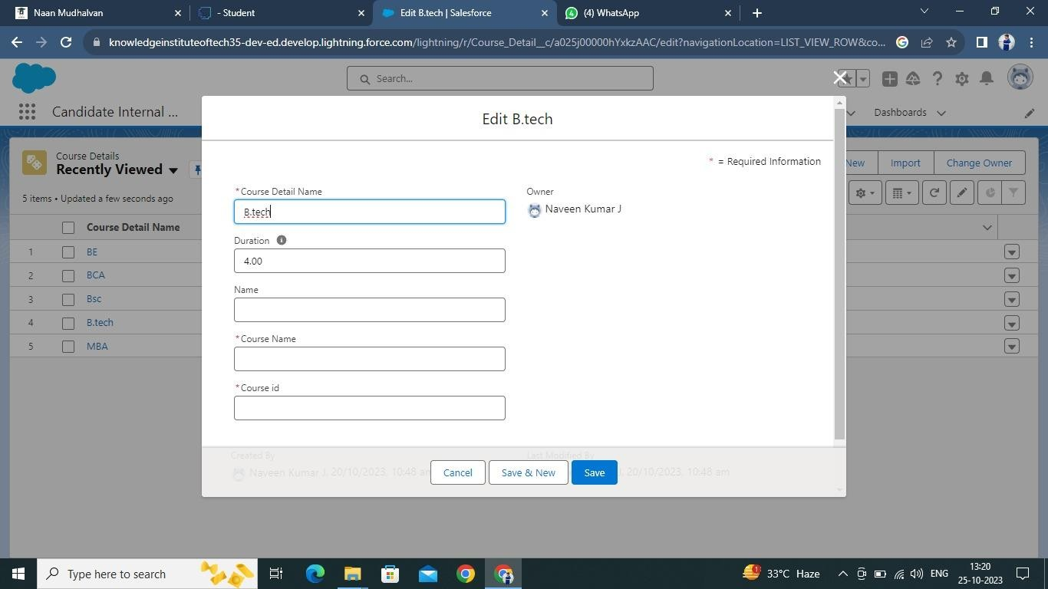

### View Record (Course Details)

1. Click on App Launcher on left side of screen.
2. Search **Candidate Internal Result Card** & click on it.
3. Click on **Course details** Tab.
4. Click on any record name. you can see the details of the Driver.

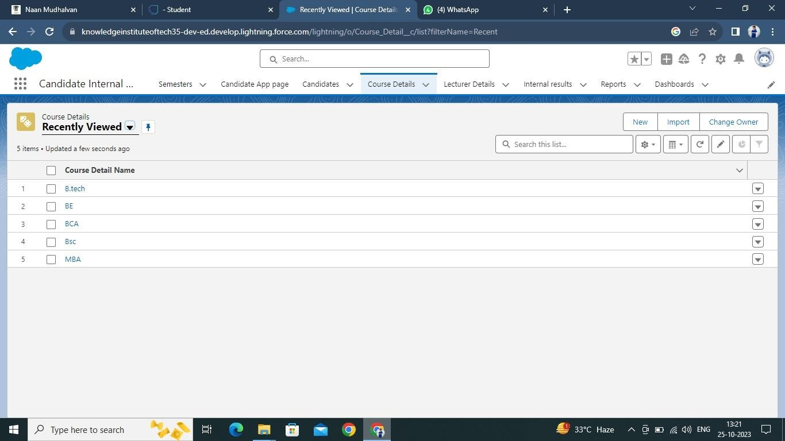

### Delete Record (Course Details)

1. Click on App Launcher on left side of screen.
2. Search **Candidate Internal Result Card** & click on it.
3. Click **on Course details** Tab.
4. Click on Arrow at right hand side on that Particular record.
5. Click delete and delete again.

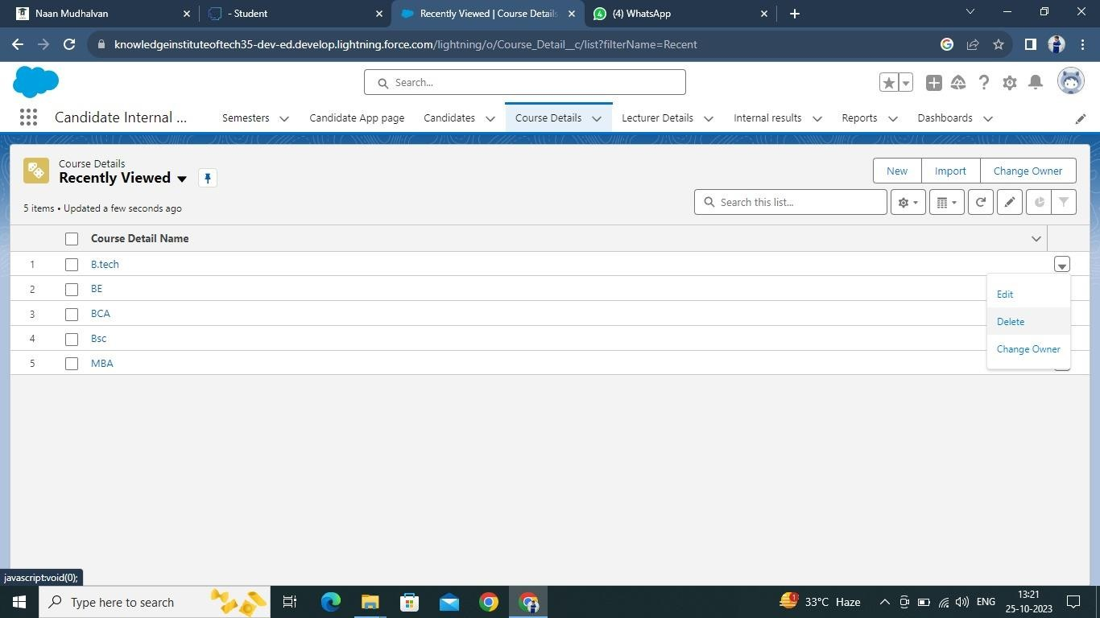

### What Are Reports?

Reports in Salesforce is a list of records that meet a particular criterion which gives an answerto a particular question. These records are displayed as a table that can be filtered or grouped based on any field.

There are 4 types of report formats in Salesforce:

#### Tabular Reports:

This is the most basic report format. It just displays the row of records in a table with a grand total. While easy to set up they can’t be used to create groups of data or charts and also cannot be used in Dashboards. They are mainly used to generate a simple list or a list with a grand total.

#### Summary Reports:

It is the most commonly used type of report. It allows grouping of rows of data, view sub total,and create charts.

#### Matrix Report:

It is the most complex report format. Matrix report summarizes information in a grid format. It allows records to be grouped by both columns and rows. It can also be used to generate dashboards. Charts can be added to this type of report.

#### Joined Reports:

These types of reports let us create different views of data from multiple report types. The data is joined reports are organized in blocks. Each block acts as a sub report with its own fields, columns, sorting, and filtering. They are used to group and show data from multiple report types in different views.

#### Report types*:*

Report type determines which set of records will be available in a report. Every report is based on a particular report type. The report type is selected first when we create a report. Every report type has a primary object and one or more related objects. All these objects must be linked together either directly or indirectly.

* A report type cannot include more than 4 objects.
* Once a report is created its report type cannot be changed.

There are 2 types of report types:

#### Standard Report Types:

Standard Report Types are automatically included with standard objects and also with custom objects where “Allow Reports” is checked.

Standard report types cannot be customized and automatically include standard and custom fields for each object within the report type. Standard report types get created when an object is created, also when a relationship is created.

**Note:** *Standard report types always have inner joins.*

#### Custom Report Types:

Custom report types are reporting templates created to streamline the reporting

process. Custom Reports are created by an administrator or User with “Manage Custom

Report Types” permission. Custom report types are created when standard report types cannot specify which records will be available on reports.

In custom report types we can specify objects which will be available in a particular report.

The primary object must have a relationship with other objects present in a report type either directly or indirectly.

There are 3 types of access levels of folders:

#### Viewer:

With this access level, users can see the data in a report but cannot make any changes except cloning it into a new report.

#### Editor:

With this access level, users can view and modify the reports it contains and can also move themto/from any other folders they have access level as Editor or Manager.

#### Manager:

With this access level, users can do everything Viewers & Editors can do, plus they can alsocontrol other user’s access levels to this folder. Also, users with Manager Access levels can delete the report.

### Create Report

1. Click App Launcher
2. Select **Candidate Internal Result Card** App
3. Click reports tab
4. Click New Report.
5. Click the report type as Semesters with Course Click **Start report.**
6. Customize your report, in group rows select - **Course Name**, in

group column Select **Duration** (In this way we are making a Matrix Report).

1. Click refresh
2. Click save and run
3. Give report name – **Candidate Internal Result Report**
4. Click Save

**NOTE:** In this report you can see your all record of the object you selected for reporting (What

you Selects in “Select a report type option”).

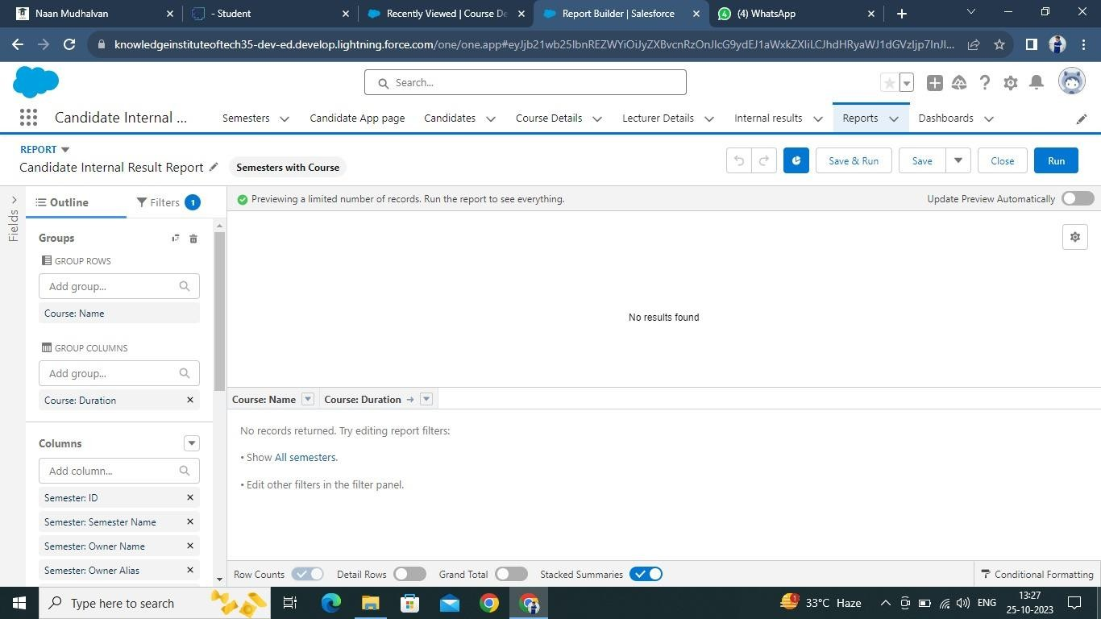

### View Report

1. Click on App Launcher on left side of screen.
2. Search **Candidate Internal Result Card** App & click on it.
3. Click on Reports Tab.
4. Click on **Candidate Internal Result Report** and see records.

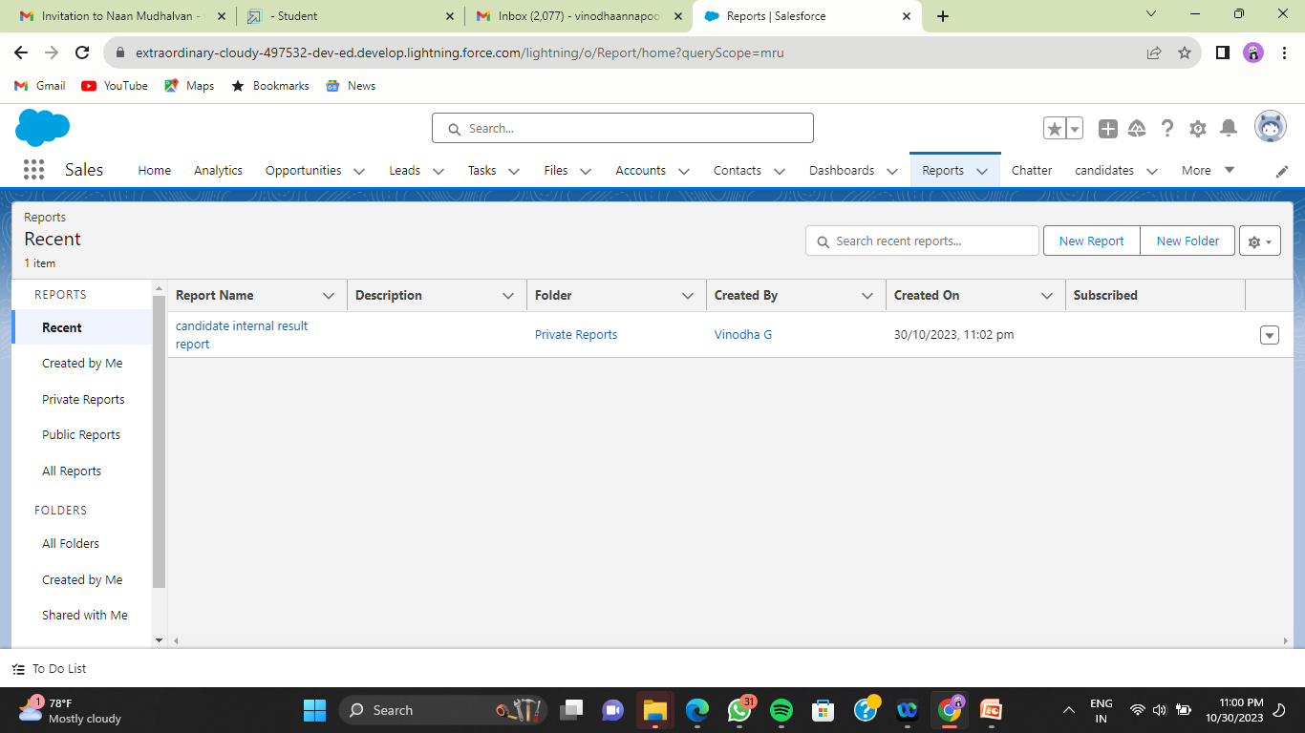

### Dashboards

Dashboards let you curate data from reports using charts, tables, and metrics. If your colleagues need more information, then they' reable to view your dashboard's data-supplying reports.

Dashboard filters make it easy for users to apply different data perspectives to a single dashboard.

### Create Dashboard

* 1. Click on Dashboards tab from the **Candidate Internal Result Card**

application.

* 1. Click on new dashboard.
  2. Give name- **Candidate Internal Result Card**
  3. Click create
  4. Give your dashboard a name and click on +component
  5. Select the **Candidate Internal Result** Report which you created.
  6. For the data visualization select any of the chart, table etc. as per your choice/requirement.
  7. Click add.
  8. Click save.

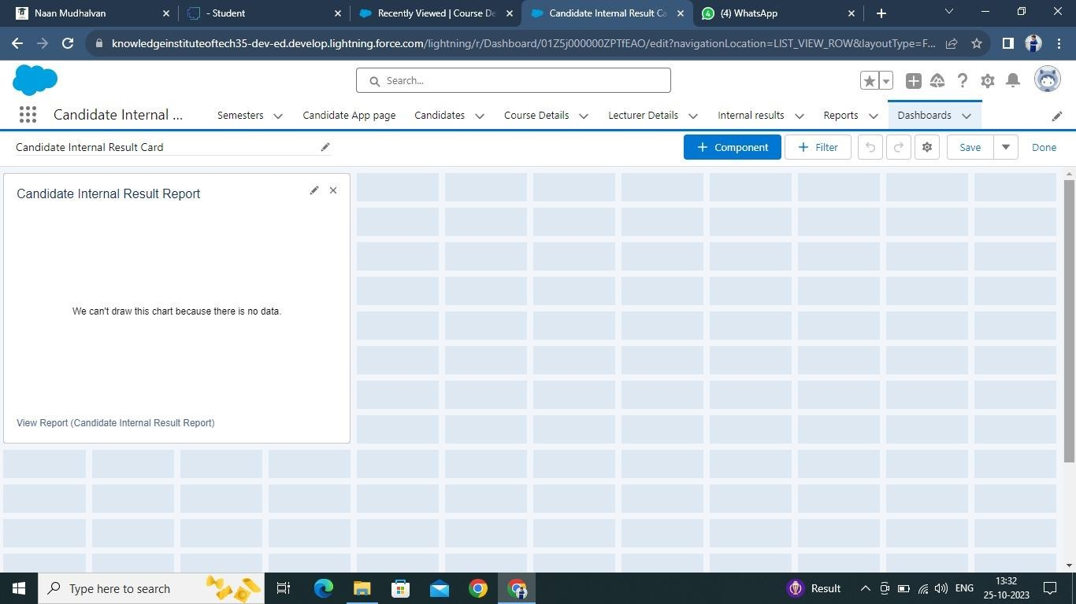

**View Dashboard**

1. Click on App Launcher on left side of screen.
2. Search **Candidate Internal Result Card** & click on it.
3. Click on Dashboard Tab.
4. Click on **Candidate Internal Result Card** see graph view of records.

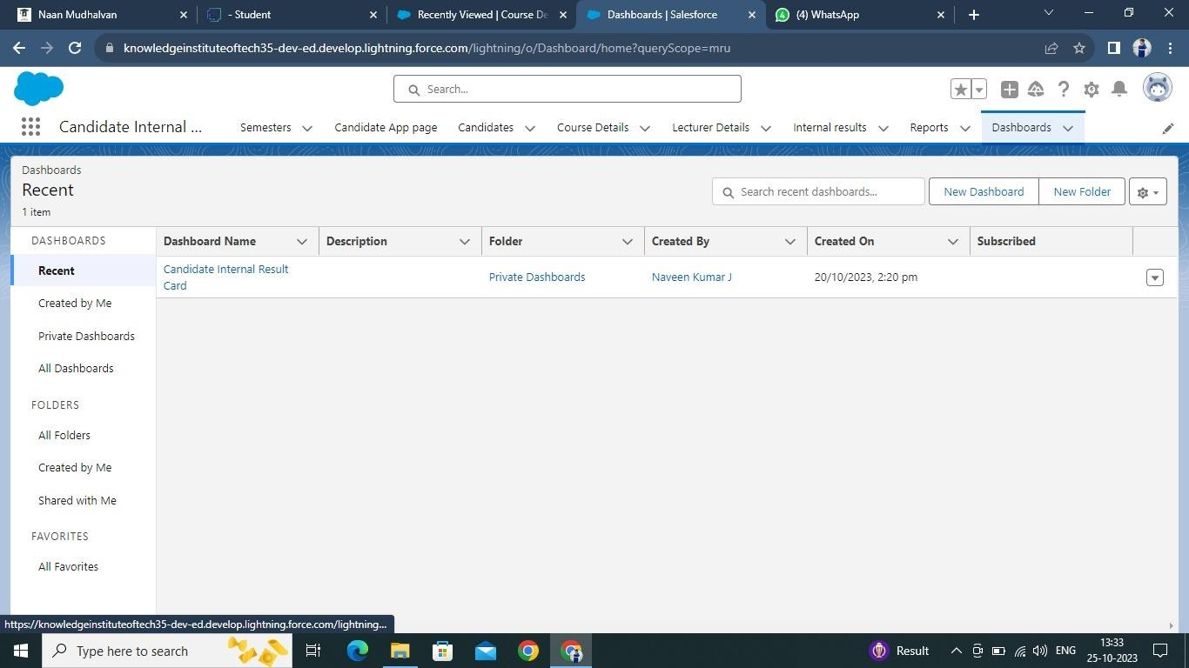

# 4. USERS & DATA SECURITY

#### Profile

A profile is a group/collection of settings and permissions that define what a user can do in salesforce. A profile controls “Object permissions, Field permissions, User permissions, Tab settings, App settings, Apex class access, Visualforce page access, Page layouts, Record Types, Login hours & Login IP ranges. A profile can be assigned to many users, but user can be assigned single profile at a time.

#### Create A Custom Profile

1.From setup, enter profiles in Quick Find box 2.Select profiles (Standard user).

1. Click clone.
2. For Profile, enter Recruiter. 5.Click save.

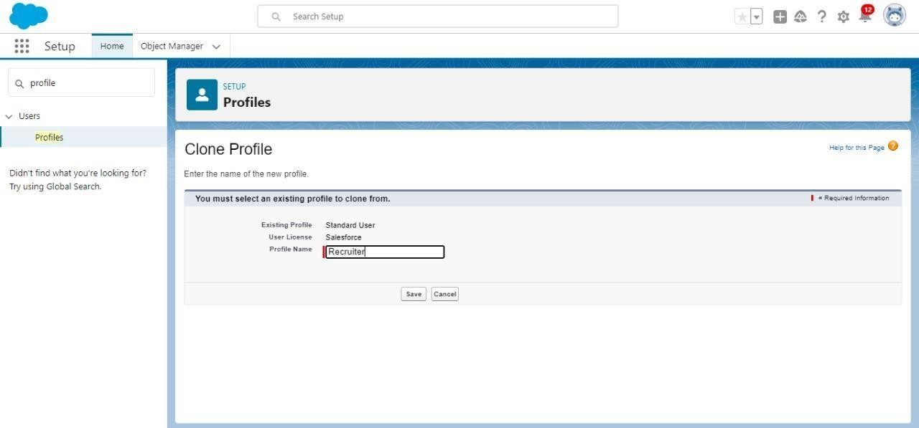

#### Create A Custom Profile-2

1.Create a profile with the profile name as “Sales Manager”. 2.From setup, enter profiles in Quick Find box

3.Select profiles (Standard user). 4.Click clone.

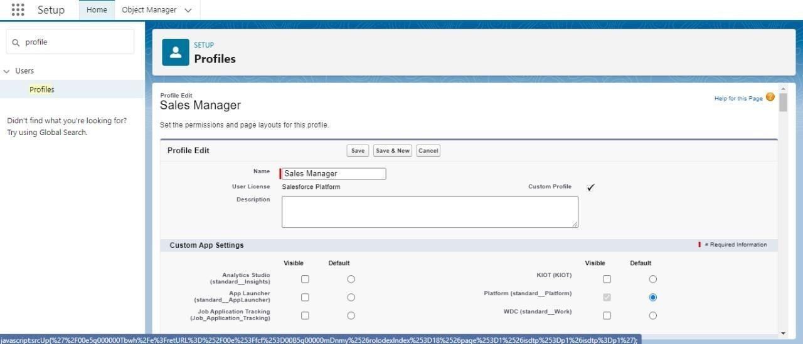

#### Role

In Salesforce, roles are used to determine which users have

access to certain data and functions within the system. They are also used to define the reporting hierarchy within an organization. Users with higher roles have greater access to data and more control over the system

#### 1)Creation of Role

1. From the Quick find box search for the role and click on the roles option
2. select the set-up roles option
3. Below the CEO click on add role and enter the label name as a” HR Manager” and role name will be Automatically populated and click on save.

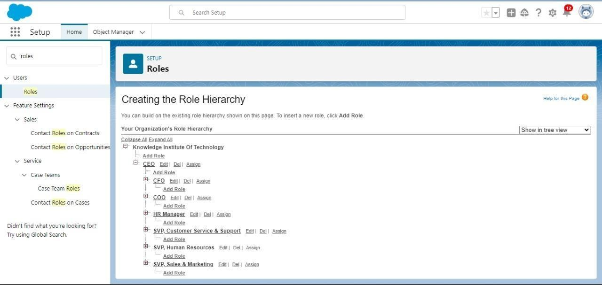

#### User

A user is anyone who logs in to Salesforce. Users are employees

at your company, such as sales reps, managers, and IT specialists, who need access to the company's records. Every user in Salesforce has a user account. The user account identifies the user, and the user account settings determine what features and records the user can access.

#### To Create A User

1.From Setup, enter Users in the Quick Find box, then select Users. 2.Click New User.

1. Enter First name as HR and last name as Manager.
2. Enter the user’s name and email address and a unique username in the form of an email address. By default, the username is the same as the email address.
3. Then create a new role HR Manager.
4. Select user License as Standard Platform User. 7.Select profile (Recruiter).

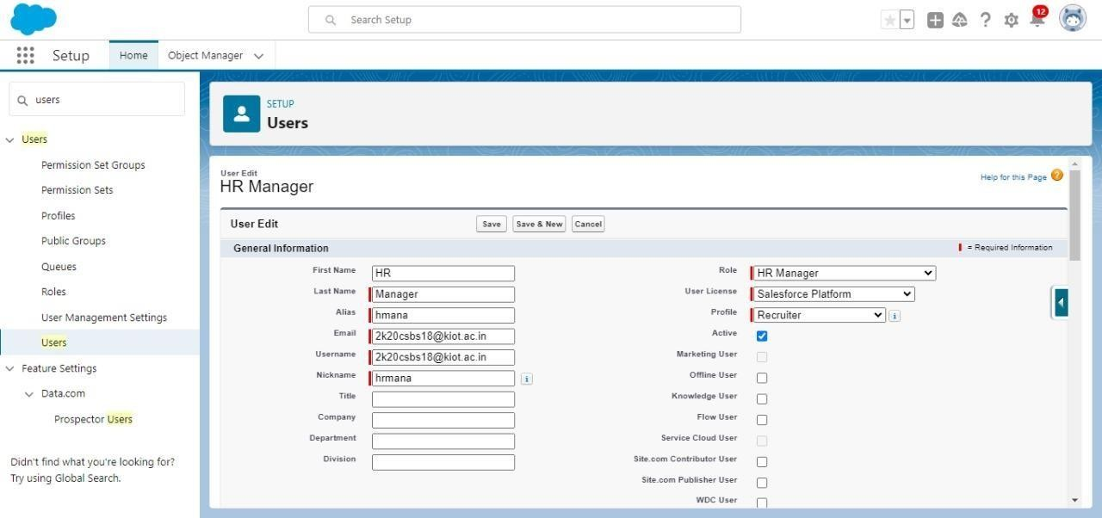

8.Click save

#### To Create A User

1.From Setup, enter Users in the Quick Find box, then select Users. 2.Click New User.

1. Enter First name as Ganesh and last name as Gili.
2. Enter the user’s name and email address and a unique username in the form of an email address. By default, the username is the same as the email address.
3. Then create a new role HR Manager.
4. Select user License as Standard Platform User. 7.Select profile (Sales Manager).

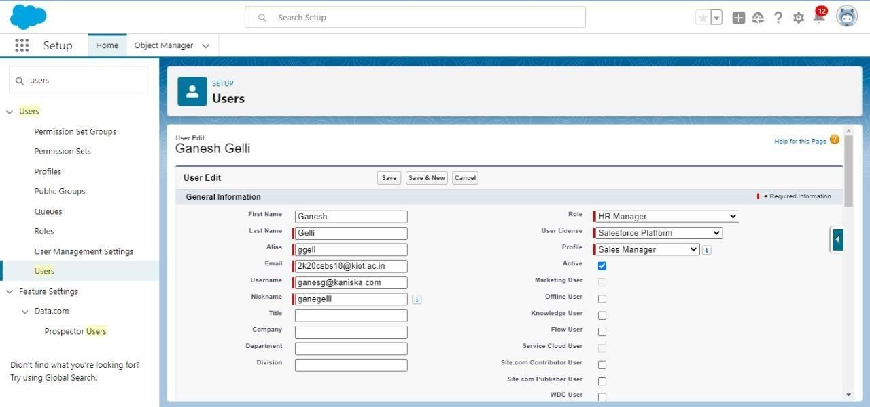

1. Click save

#### Sharing Rules

Sharing rules help users to share records based on conditions. It is basically created for objects whose organization-wide defaults (OWD) are set to public read-only or private because sharing rules can only extend the access and not restrict it.

Types of sharing rules,

* 1. Owner-based Sharing Rules 2.Criteria-based Sharing Rules

#### Create A Sharing Rule

1. Go to Sharing Settings, which can be found under the Quick Find section.
2. Scroll down and find the candidate object where a sharing rule needs to be added, and then click on New to create a new sharing rule.
3. Add the label of the sharing rule you want to make. 4.Select your rule type based on the criteria.
4. Select the field can join immediately check field from the candidate object.
5. Select the State as equal and value is Rajasthan.
6. And in selecting the users to share with the section select roles and in that select Hr Manager.
7. And in the section of select the level of access for the users give the access Read/Write.
8. And save the rule.

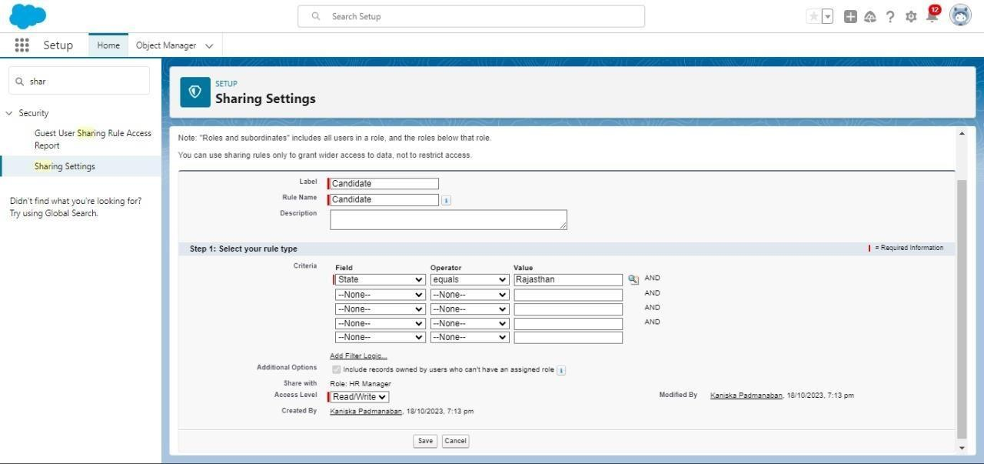

#### Activity 2

Create a Sharing Rule to Share the records of Job Application to Hr Manager with the Access of Read/Write.

#### Create A Sharing Rule

1. Go to Sharing Settings, which can be found under the Quick Find section.
2. Scroll down and find the Job Application object where a sharing rule needs to be added, and then click on New to create a new sharing rule.
3. Add the label of the sharing rule you want to make. 4.Select your rule type based on the criteria.
4. Select the field can join immediately check field from the Job Application object.
5. Job application number contains some number.
6. And in selecting the users to share with the section select roles and in that select Hr Manager.
7. And in the section of select the level of access for the users give the access Read/Write.
8. And save the rule.

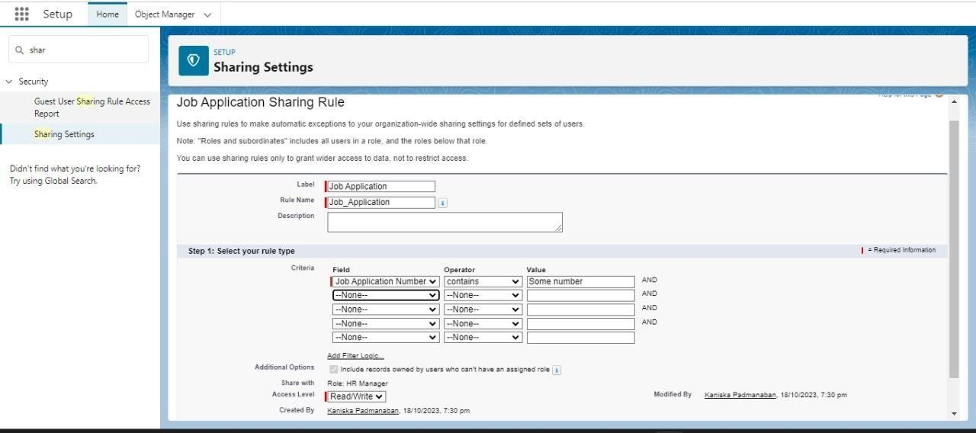

#### Flow:

1. **AUTOMATION**

Flows in Salesforce, a flow is a tool that automates complex business processes. Simply put, it collects data and then does something with that data. Flow Builder is the declarative interface used to build individual flows. Flow Builder can be used to build code-like logic without using a programming language. Flows fall into five categories:

* 1. Screen Flows
  2. Schedule-Triggered Flows 3.Autolaunched Flows 4.Record-Triggered Flows

5.Platform Event-Triggered Flows **1)Create A Record Trigger Flow on Job Object** 1.Click on Gear icon and select setup

2.In Quick find Box enter flow and select the flows 3.Click on New flow and Select Record triggered Flows.

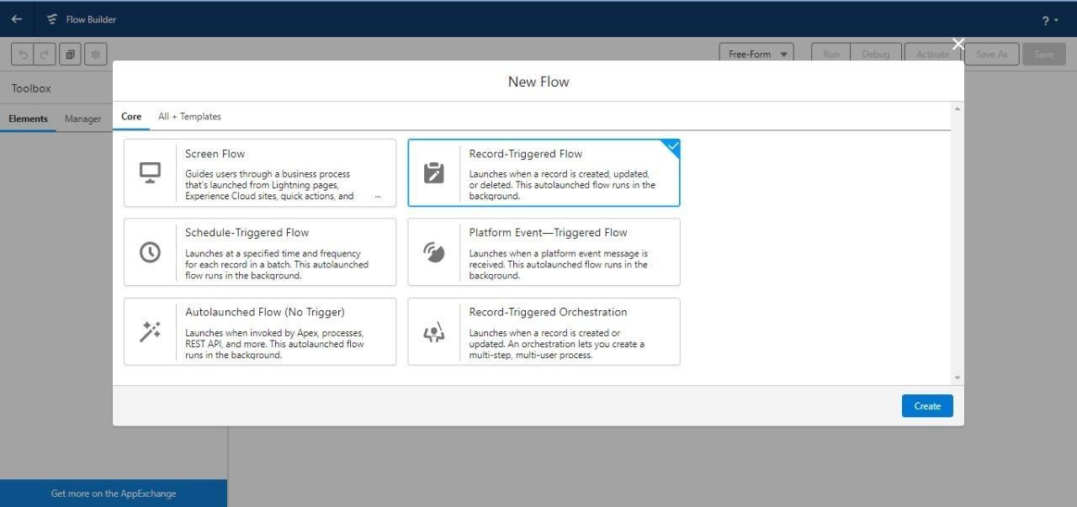

1. In the search bar type job and click done.

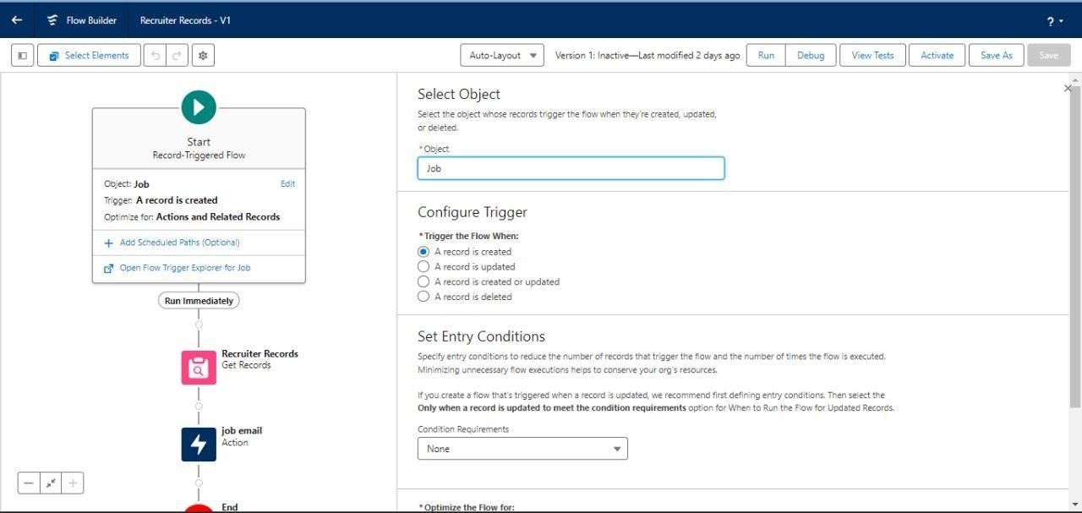

1. Add an element called Get record. 6.Label name as Recruiter Records. 7.Select the object as Recruiter.

8.After entering the object follow the steps.

10.Conditional requirements should be all conditions are met (AND). 11.Select the field as Recruiter_Email c.

1. Operation should be Is Null.
2. Value should be False. And click done.

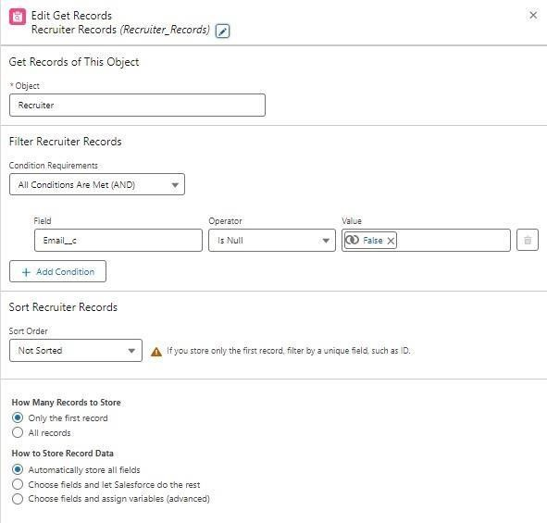

1. Add another element called Action.
2. Click on the Action and start creating new action 16.Select the action as Send Email.
3. Enter the label name job email, API name is auto populated. 18.Set input values as
   1. Body: {!$Record.Name} with

{!$Record.Job_Application_Id c} is available. Please find the suitable candidates for the position.

* 1. Subject: {!$Record.Name}

1. Recipient Email Addresses (comma-separated) should be included for that turn it on.
2. Recipient Email Addresses:

{!$Record.Recruiter_Name r.Recruiter_Email c}

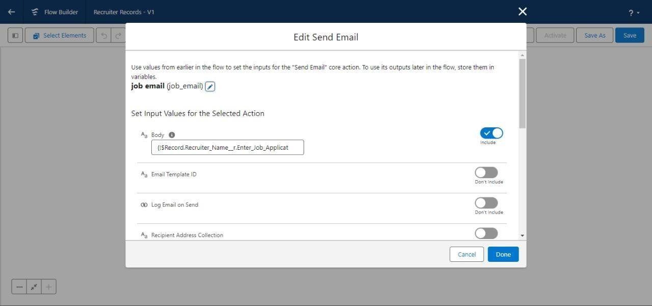

1. Click on done.
2. After the completion of flow, check whether the flow is running and click save.
3. And Activate the flow.

#### 2)Create Another Flow

1. Click on Gear icon and select setup
2. In Quick find Box enter flow and select the flows 3.Click on New flow and Select Screen Flows.

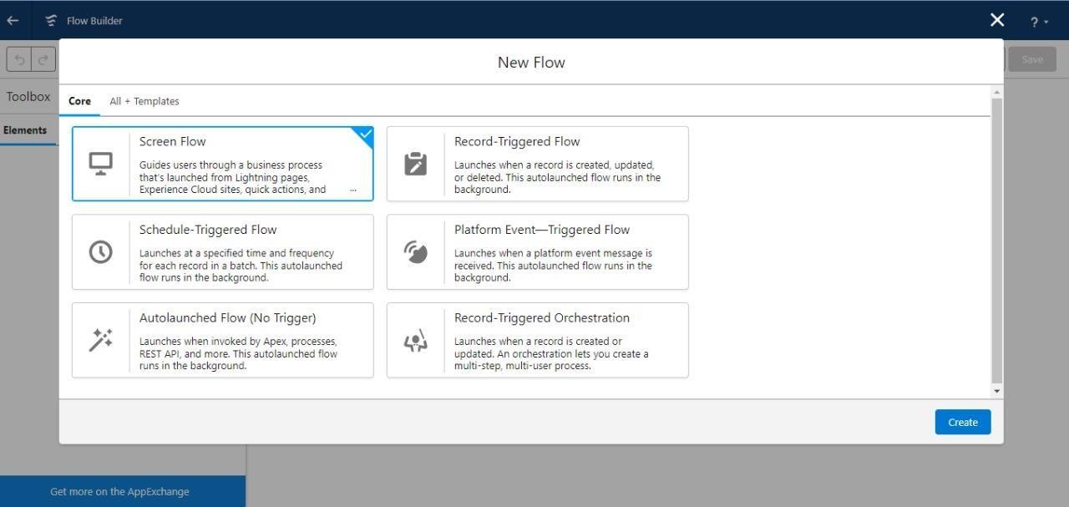

1. Add an element called screen.
2. Screen label should be Candidate details. 6.API name is auto populated.

7.Add the components in canvas. 8.Select the text from the components. 9.Label name as Candidate name.

1. API name is auto populated.
2. Select the text area from the components. 12.Label name as Address.
3. API name is auto populated.
4. Select the email from the components. 15.Label name as Email.
5. API name is auto populated.
6. Select the Phone from the components. 18.Label name as Phone.
7. API name is auto populated.
8. Select the picklist from the components.
9. Label name as Education. 22.API name is auto populated. 23.And select the choice as {!pick}.

24.Add a header to the canvas candidate flow for job application. 25.Click on save.

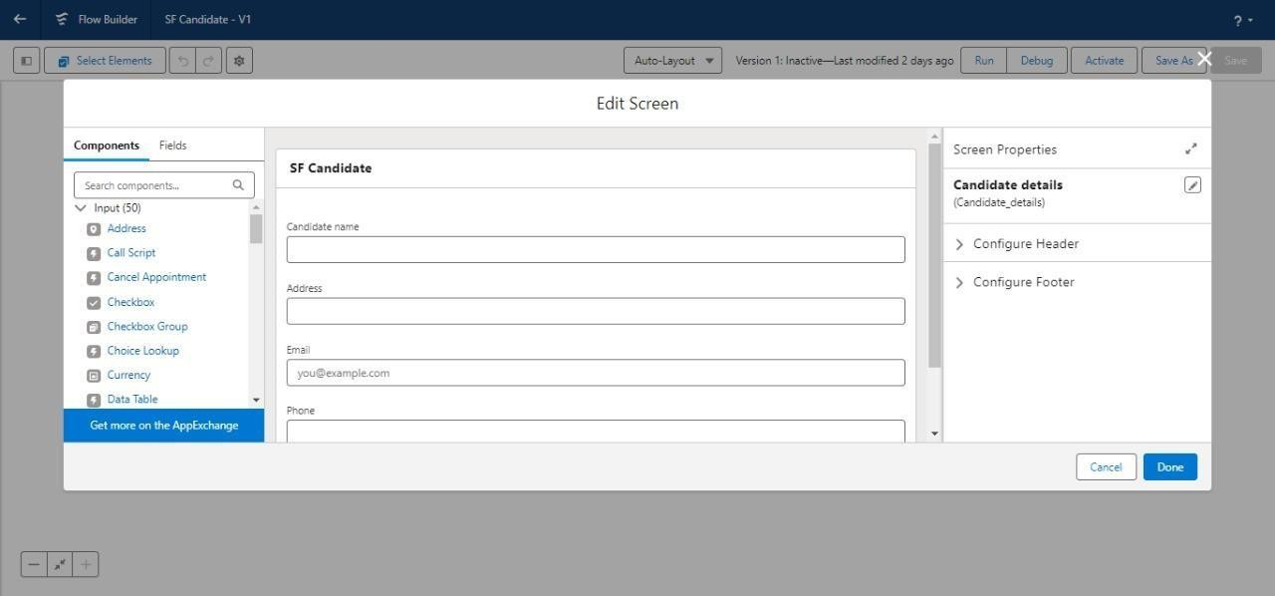

26.Next, add another element called create record. 27.Label name should be Create candidate record.

1. API is auto populated. and change the How to Set the Record Fields to Use separate resources, and literal values.
2. Select the object Candidate1.

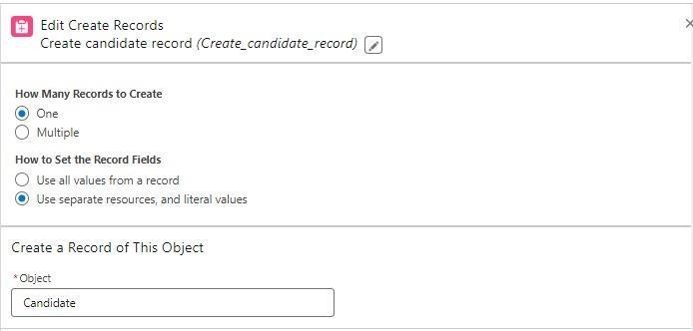

1. Set the values for the candidate1 as
2. Field is Address c and value should be {!Address}. 32.Field is Education c and value should be {!Education}. 33.Field is Email c and value should be {!Email.value}. 34.Field is Name and value should be {!Candidate_name}. 35.After that click on done.

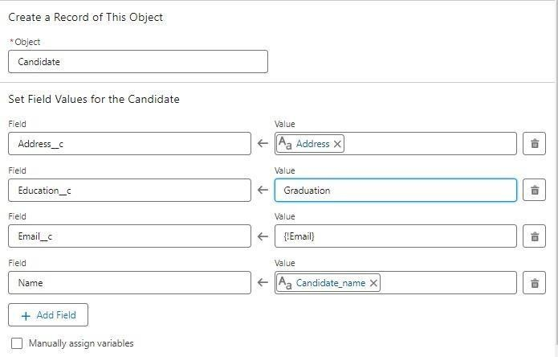

1. Run the flow and check whether the flow is working and click on save.
2. And activate the flow.

#### Reports

1. **REPORTS & DASHBOARD**

A report is a list of records that meet the criteria you define. It's displayed in rows and columns, and can be filtered, grouped, or displayed in a graphical chart. Every report is stored in a folder.

Folders can be public, hidden, or shared, and can be set to read-only or read/write.

There are 4 types of report formats in Salesforce:

#### Tabular Reports:

This is the most basic report format. It just displays the row of records in a table with a grand total. While easy to set up they can’t be used to create groups of data or charts and also cannot be used in Dashboards. They are mainly used to generate a simple list or a list with a grand total.

#### Summary Reports:

It is the most commonly used type of report. It allows grouping of rows of data, view sub total,and create charts.

#### Matrix Report:

It is the most complex report format. Matrix report summarizes information in a grid format. It allows records to be grouped by both columns and rows. It can also be used to generate dashboards. Charts can be added to this type of report.

#### Joined Reports:

These types of reports let us create different views of data from multiple report types. The data is joined reports are organized in

blocks. Each block acts as a sub report with its own fields, columns, sorting, and filtering. They are used to group and show data from multiple report types in different views.

#### Report types*:*

Report type determines which set of records will be available in a report. Every report is based on a particular report type. The report type is selected first when we create a report. Every report type has a primary object and one or more related objects. All these objects must be linked together either directly or indirectly.

* A report type cannot include more than 4 objects.
* Once a report is created its report type cannot be changed.

There are 2 types of report types:

#### Standard Report Types:

Standard Report Types are automatically included with standard objects and also with custom objects where “Allow Reports” is checked.

Standard report types cannot be customized and automatically include standard and custom fields for each object within the report type. Standard report types get created when an object is created, also when a relationship is created.

**Note:** *Standard report types always have inner joins.*

#### Custom Report Types:

Custom report types are reporting templates created to streamline the reporting

process. Custom Reports are created by an administrator or User with “Manage Custom

Report Types” permission. Custom report types are created when standard report types cannot specify which records will be available on reports.

In custom report types we can specify objects which will be available in a particular report.

The primary object must have a relationship with other objects present in a report type either directly or indirectly.

There are 3 types of access levels of folders:

#### Viewer:

With this access level, users can see the data in a report but cannot make any changes except cloning it into a new report.

#### Editor:

With this access level, users can view and modify the reports it contains and can also move themto/from any other folders they have access level as Editor or Manager.

#### Manager:

With this access level, users can do everything Viewers & Editors can do, plus they can alsocontrol other user’s access levels to this folder. Also, users with Manager Access levels can delete the report.

**Create Report**

1. Click App Launcher
2. Select **Candidate Internal Result Card** App
3. Click reports tab
4. Click New Report.
5. Click the report type as Semesters with Course Click **Start report.**
6. Customize your report, in group rows select - **Course Name**, in group column Select **Duration** (In this way we are making a Matrix Report).
7. Click refresh
8. Click save and run
9. Give report name – **Candidate Internal Result Report**

10. Click Save

**NOTE:** In this report you can see your all record of the object you selected for reporting (What

you Selects in “Select a report type option”).



### View Report

1. Click on App Launcher on left side of screen.
2. Search **Candidate Internal Result Card** App & click on it.
3. Click on Reports Tab.
4. Click on **Candidate Internal Result Report** and see records.

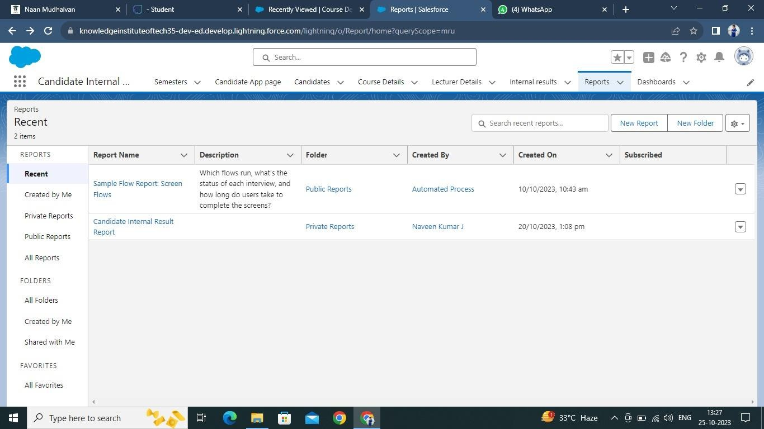

### Dashboards

Dashboards let you curate data from reports using charts, tables, and metrics. If your colleagues need more information, then they' readable to view your dashboard's data-supplying reports.

Dashboard filters make it easy for users to apply different data perspectives to a single dashboard.

### Create Dashboard

* 1. Click on Dashboards tab from the **Candidate Internal Result Card**

application.

1. Click on new dashboard.
2. Give name- **Candidate Internal Result Card**
3. Click create
4. Give your dashboard a name and click on +component
5. Select the **Candidate Internal Result** Report which you created.
6. For the data visualization select any of the chart, table etc. as per your choice/requirement.
7. Click add.
8. Click save.



**View Dashboard**

1. Click on App Launcher on left side of screen.
2. Search **Candidate Internal Result Card** & click on it.
3. Click on Dashboard Tab.
4. Click on **Candidate Internal Result Card** see graph view of records.



https://github.com/naveencsbs/Salesforce-Developer-Naan-

Mudhalavan/tree/main/Implementing%20CRM%20For%20Result%20Tracking%20Of

%20A%20Candidate%20With%20Internal%20Marks

GitHub Link

Project Video Demo Link

https://drive.google.com/file/d/1zwVmjTvrmoewGjLTB5DurIbs0VwJFuqt/v iew?usp=sharing